ROAM Analysis
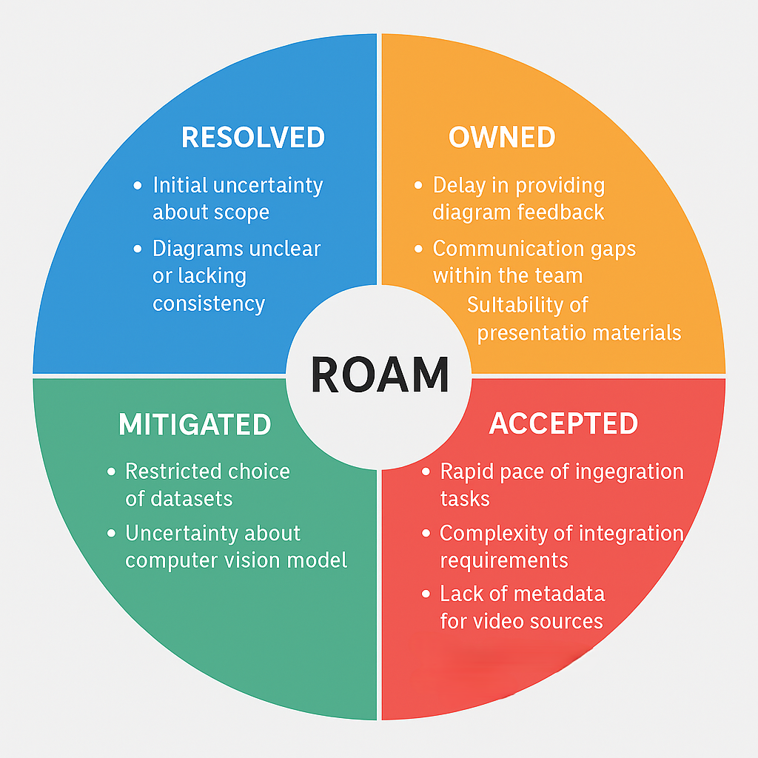
Risk | Category | Action Taken / Justification
Unclear project scope at start | Resolved | Addressed during Sprint 0 via project charter, ORK table, and mind map.
Late feedback on diagrams | Owned | Team acknowledged delay in Sprint 1 and committed to earlier sharing in future sprints.
Rushed research tasks | Accepted | Sprint 1 and 2 research was time-limited; team accepted reduced depth to maintain timeline.
Communication gaps | Owned | Identified in Sprint 1 and 2 retrospectives; team agreed to increase mid-sprint check-ins.
Dataset availability issues | Mitigated | Team explored multiple sources and shortlisted viable datasets during Sprint 2.
CV model uncertainty | Mitigated | Early testing in Sprint 2 helped identify suitable models and reduce risk.
Integration complexity | Accepted | Integration planning deferred to later sprints due to limited scope; risk acknowledged.
GIS integration complexity | Accepted | Team lacks access to geolocation metadata for video sources; map-based linking will be limited.
Diagram clarity and consistency | Resolved | Diagrams were revised and finalised in Sprint 4 for inclusion in the report.
Presentation readiness | Owned | Team assigned roles and began preparing slides and poster in Sprint 4.

